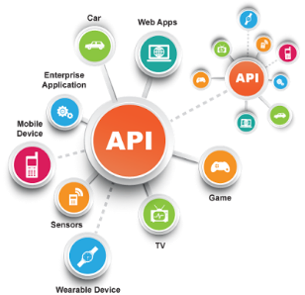**SE495 Software and Systems Integration**

**Building a Simple ETL Pipeline**

**Project Description**

In this project, students will learn how to build a simple ETL (Extract, Transform, Load) pipeline using Python and Apache Airflow. The pipeline will extract data from a CSV file, transform it using Pandas, and load it into a SQLite database. This project will give students a hands-on experience of data integration techniques, including ETL, data transformation, and mapping.

**Tools and Technologies Required:**

* Python (3.6 or higher)
* Pandas
* SQLite
* Apache Airflow

**Project Steps:**

1. Setup the environment by installing the required tools and technologies.
2. Create a sample CSV file with some dummy data.
3. Create a SQLite database and a table to store the extracted data.
4. Write a Python script that reads the CSV file using Pandas, applies some data transformation and mapping, and inserts the transformed data into the SQLite database.
5. Test the Python script to make sure it works correctly.
6. Create an Airflow DAG (Directed Acyclic Graph) that schedules and runs the Python script.
7. Test the Airflow DAG to make sure it runs correctly and loads the data into the SQLite database.

**Project Deliverables:**

1. Python script that performs the ETL pipeline.
2. SQLite database file with the extracted and transformed data.
3. Airflow DAG that schedules and runs the Python script.
4. Project report documenting the project steps, challenges faced, and best practices learned.

**Project Assessment:**

1. The correctness of the Python script and the SQLite database.
2. The functionality of the Airflow DAG.
3. The quality of the project report.